Supporting Information for

Photo-physical Properties of Donor-Acceptor-Radical Triad Based on Functionalized Tetrathiafulvalene and Nitronyl Nitroxide Radical
Haiet Douib,^{a,c} Marin Puget,^{b} Yan Suffren,^{b} Fabrice Pointillart,*ª Kevin Bernot,*^{b} Boris Le Guennic,ª Olivier Cador,ª Abdelkrim Gouasmia,^{c} Lahcène Ouahabª
ª Institut des Sciences Chimiques de Rennes, UMR 6226 CNRS-Université de Rennes 1, 263 Avenue du Général Leclerc, 35042 Rennes Cedex, France
^{b} Institut des Sciences Chimiques de Rennes, UMR CNRS 6226, INSA Rennes, 20 Avenue des buttes de Coesmes, 35708 Rennes, France.
^{c} Laboratoire des Matériaux Organiques et Hétérochimie (LMOH), Département des sciences de la matière, Université Larbi Tébessi de Tébessa, Route de Constantine 12002, Tébessa, Algérie.
Corresponding authors: fabrice.pointillart@univ-rennes1.fr; kevin.bernot@insa-rennes.fr

Fig. S1. ORTEP view of 2. Thermal ellipsoids are drawn at 30% probability. Hydrogen atoms are omitted for clarity.

Fig. S2. Packing view of 2 in the (010) direction. Hydrogen atoms are omitted for clarity.

Fig. S3. First derivative of the cyclic voltammogram of 3 in oxidation (black curve) and reduction (gray curve) highlighting the three oxidation potentials.

Fig. S4. Experimental UV/vis absorption spectra in solution (c = 4·10⁻⁵ M) of 1 (open triangles), 2 (open squares) and 3 (open circles) in CH₂Cl₂.

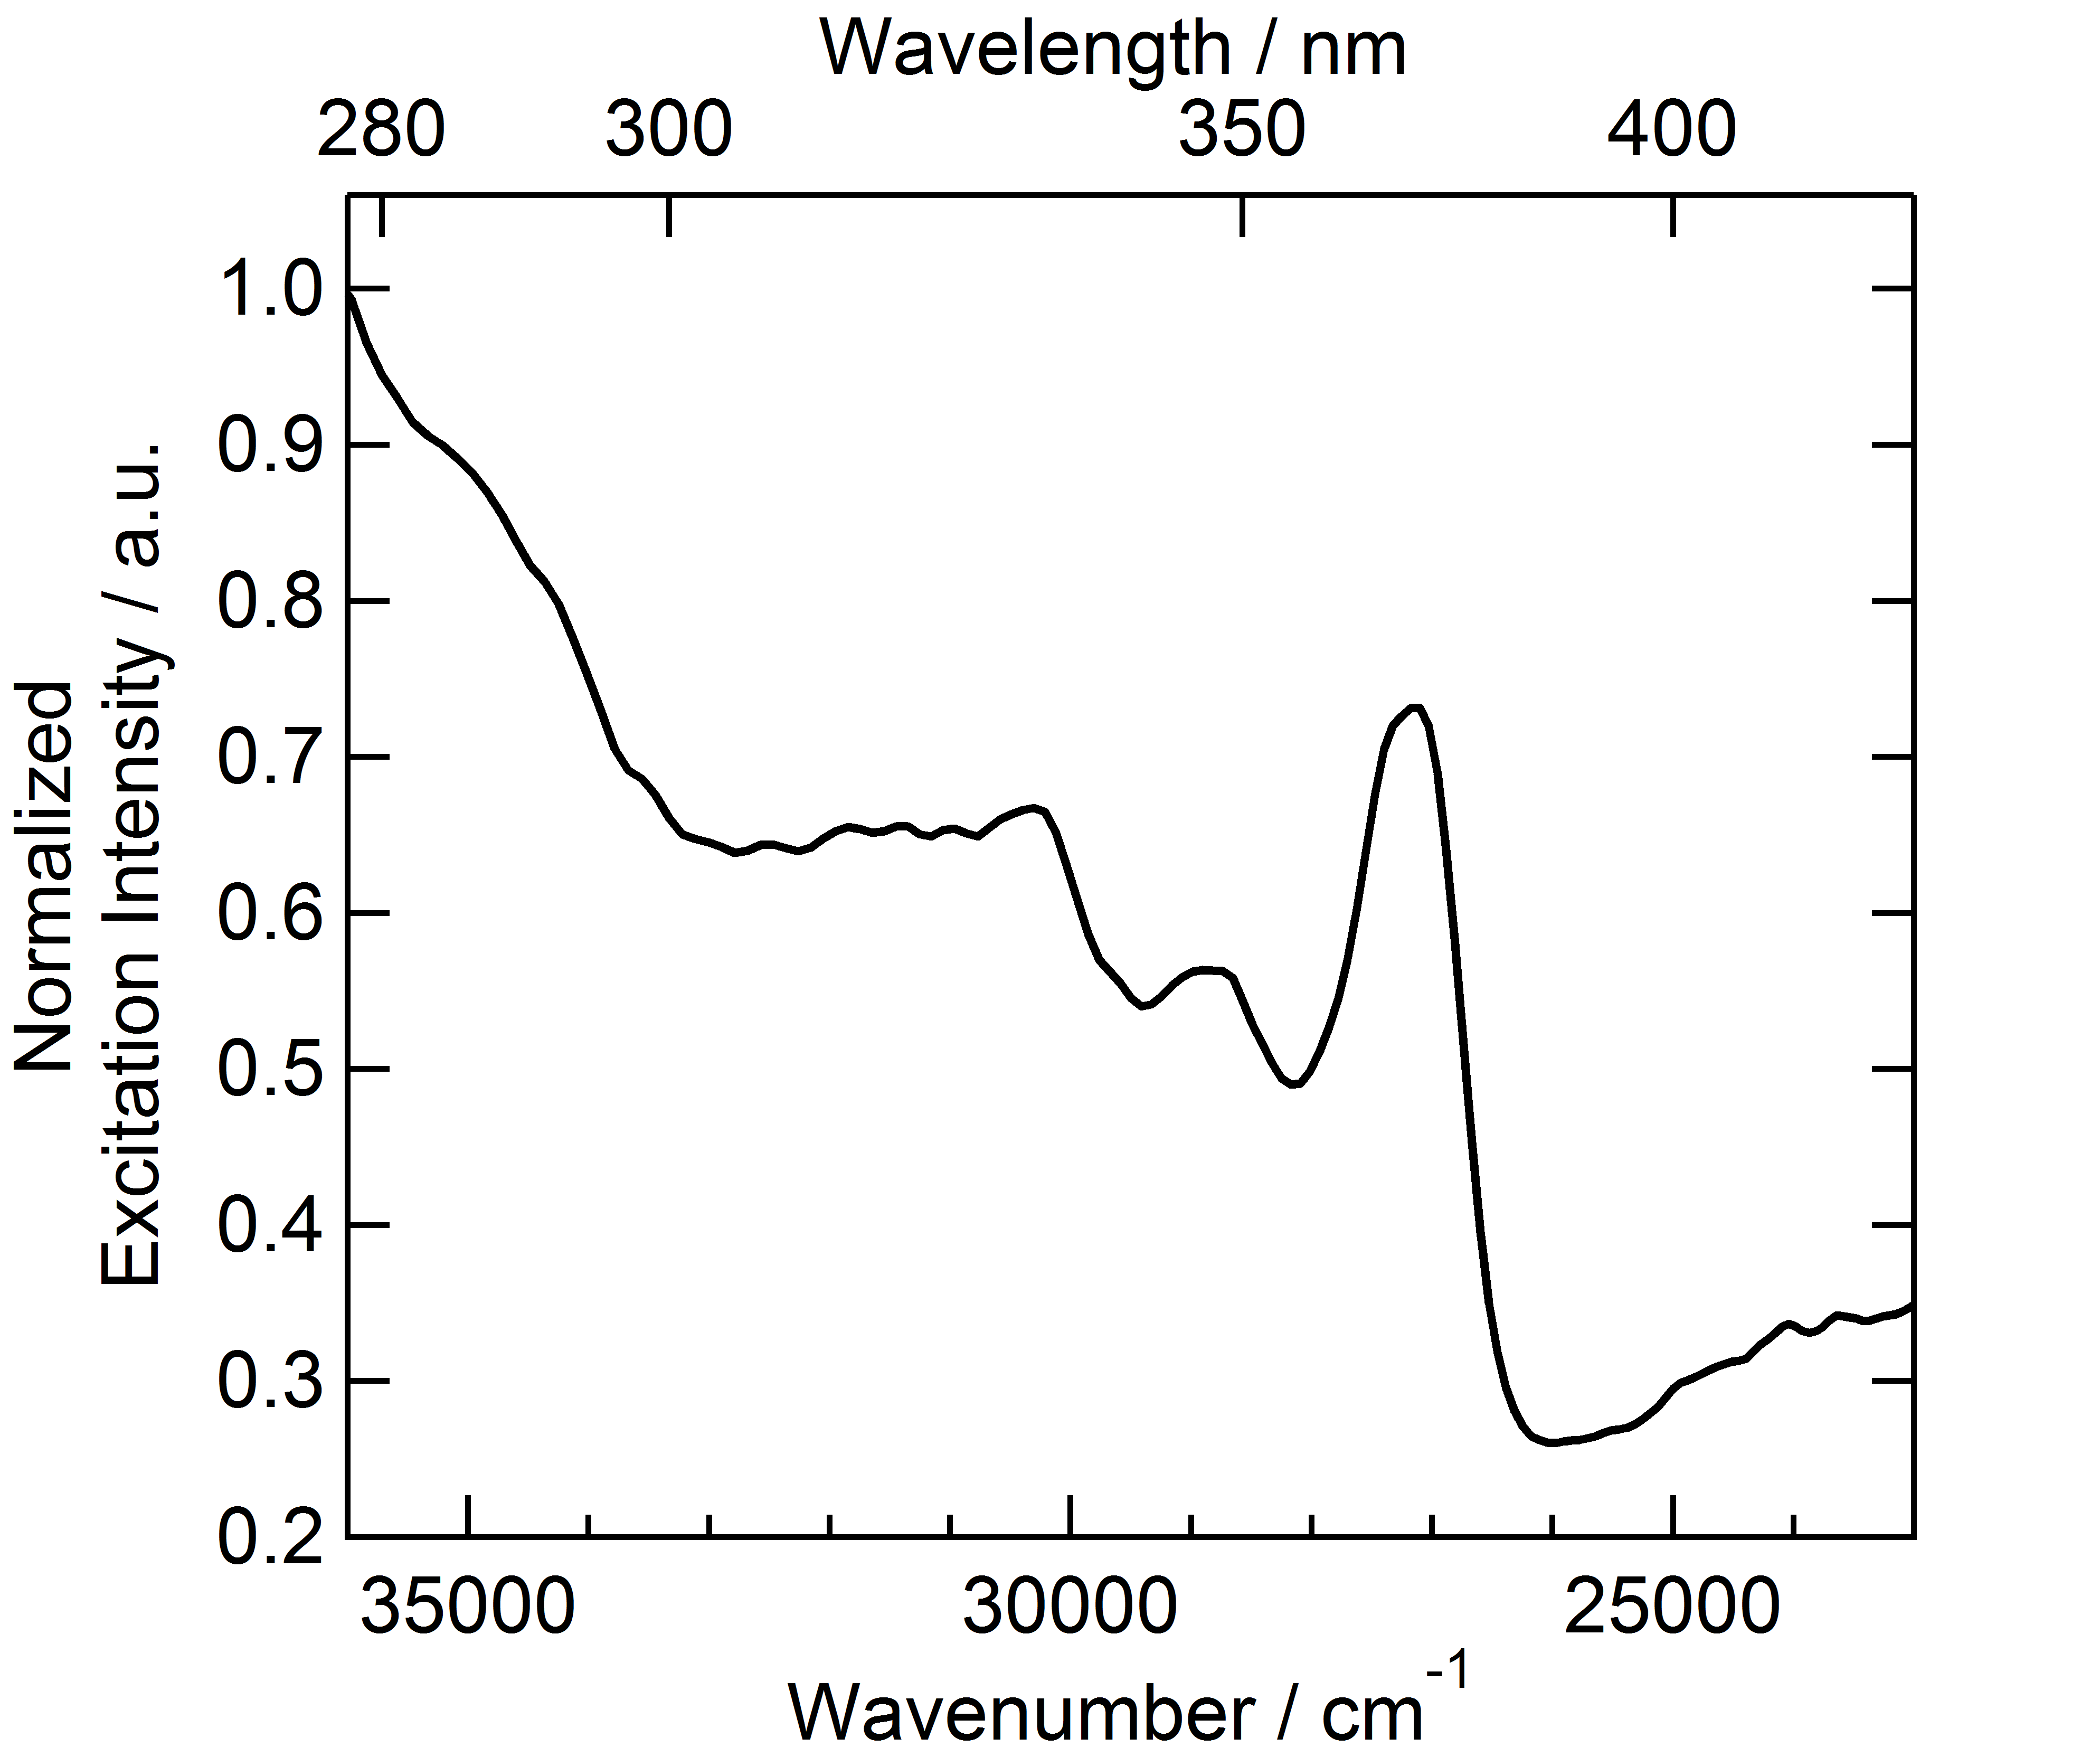
Fig. S5. Excitation spectrum of 3 (λ_{em} = 14388 cm⁻¹ (695 nm)) in CH₂Cl₂ solution (C = 1.9×10⁻⁵ M) at 77 K.

Fig. S6. Experimental UV/vis absorption (open circles) and excitation (open squares) spectra in solution (c = 4·10⁻⁵ M) of 3 in CH₂Cl₂.

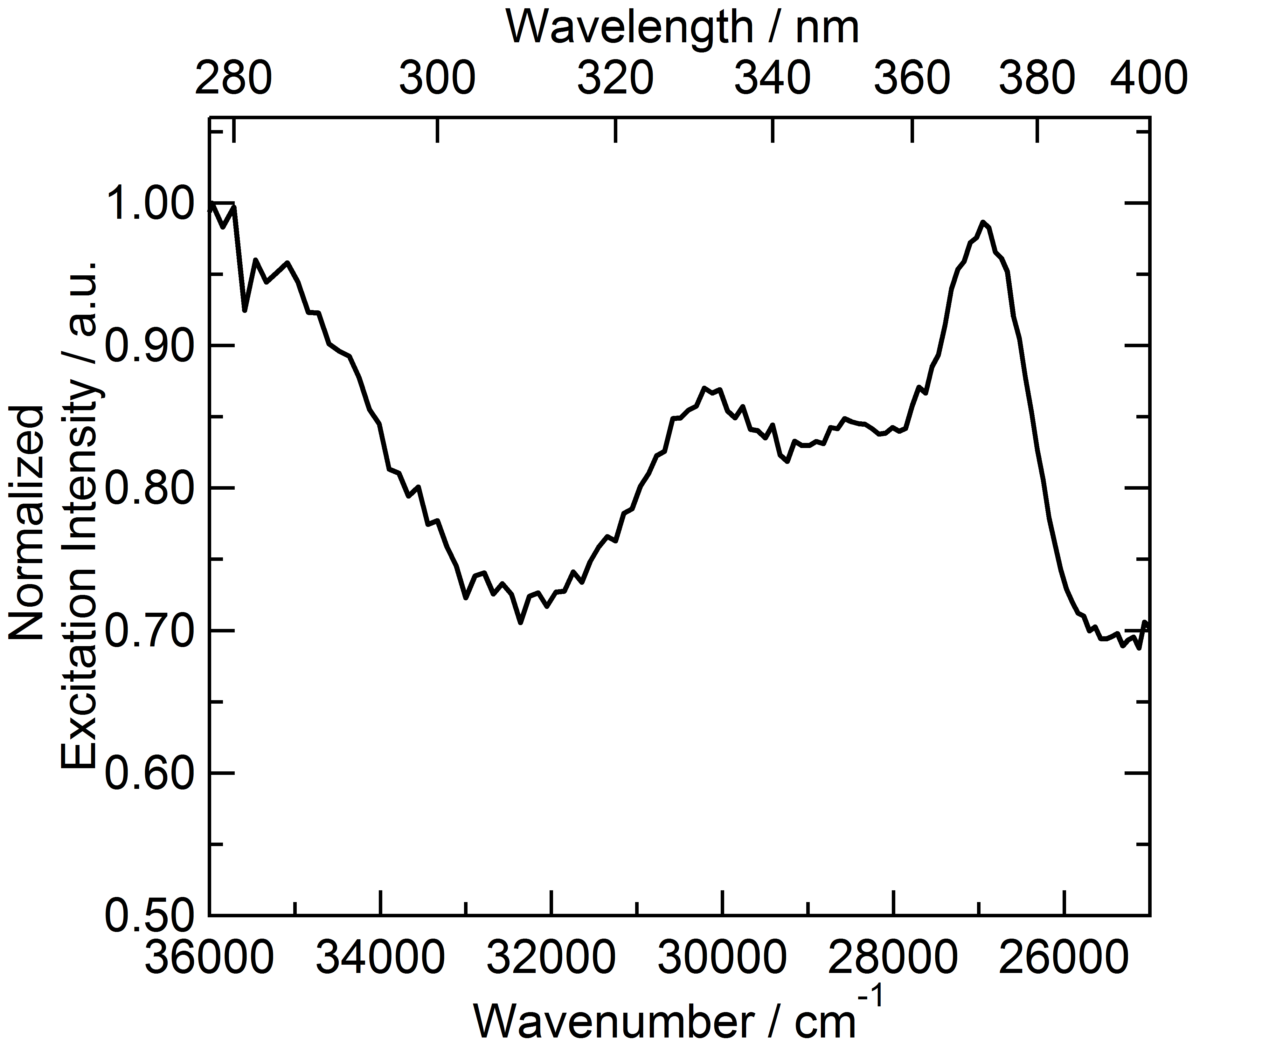
Fig. S7. Solid-state excitation spectrum of 3 (λ_{em} = 13605 cm⁻¹ (735 nm)) at 77 K.

