Supplementary Information for the Manuscript:
“COMPARATIVE STUDY ON STRUCTURAL, MAGNETIC AND SPECTROSCOPIC PROPERTIES OF FOUR NEW COPPER(II) COORDINATION POLYMERS WITH 4’-substituted TERPYRIDINE LIGANDS”
By the authors:
Dominique Toledo,¹ Andrés Vega,² Ricardo Baggio,³ Nancy Pizarro,² Octavio Peña,⁴ Thierry Roisnel,⁴ Jean-Yves Pivan,^{4,5} Yanko Moreno*²

Figure S1. ¹H NMR spectrum of 3-qtpy ligand

Figure S2. ¹³C NMR spectrum of 3-qtpy ligand
IR- Compounds I-IV
Figure S3. IR spectrum of Compound I-IV
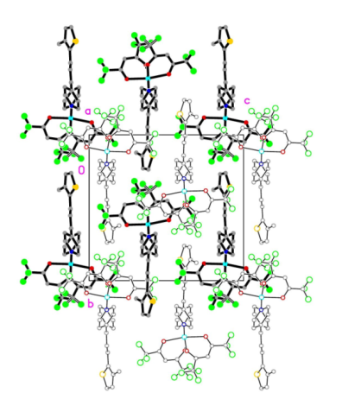(a) | 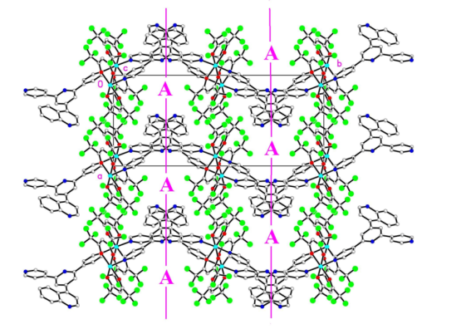(b)
Fig. S4: a) Packing view of I, projected along the chains direction [100]. Contiguous chains drawn in different blackness, for clarity. b) Packing view of II, projected perpendicular to the chains direction. Vertical lines at y ≈ 0.25, 0.75. The c glide planes shown in projection. Solvates not shown to clarify the position and size of the central focus (labelled (A)) occupied by the solvates in disordered manner.
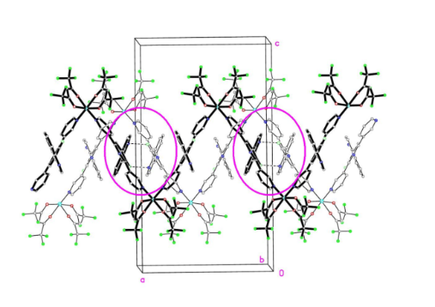(a) | 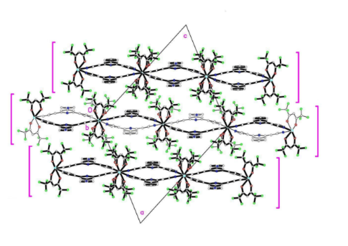(b)
Fig. S5: a) The wavy (001) arrays in III, made up by the interaction of parallel [100] chains through a set of C-H···N bonds (encircled). b) Neighbouring chains in IV, related by the set of screw axis directed along b. Note their internal structure, alternating peaks and troughs in projection, and generating a set of double undulating sheets parallel to the (-101) plane.
Table S 1
Hydrogen Bonds for I, II, III and IV.
Compd | D-H···A | d(D···H)(Å) | d(H···A)(Å) | d(D···A)(Å) | <(D-H···A) (°)
I | C20–H20C···F5BA^{ii} | 0.96 | 2.47 | 3.4065 (7) | 167
II | C1S–H1SA..N4^{ii} | 0.98 | 2.47 | 3.229 (18) | 134
 | C1S -Cl3S···Cg2^{iii} | 1.35 | 3.405 (6) |  | 145
III | C7–H7···N4^{ii} | 0.95 | 2.51 | 3.218 (4) | 131
 | C20–H20···Cl2S^{iii} | 0.95 | 2.75 | 3.635 (4) | 155.2(3)
IV | C12 –H12···O1A^{iii} | 0.95 | 2.53 | 3.377(5) | 149
Symmetry codes for I: (ii) -1/2+x,1/2-y,1/2+z; for II: (ii) -1-x,-1/2+y,-1/2-z; (iii) -x,2-y,-z ; for III (ii): -x,-y,-z (iii):-x,-y,1-z ; for IV: (iii):1/2-x,-1/2+y,3/2-z

Table S 2
π-π contacts for III
Group 1/Group2 | ccd (Å) | da (°) | ipd (Å) | sa(°)
Cg4···Cg4^{ii} | 3.730 (3) | 0 | 3.612(3) | 0.929
Cg4···Cg5^{ii} | 3.974(2) | 1.36(12) | 3.622(4) | 1.636
Ring codes: as in Fig 2. Symmetry codes (ii):-x,-y,-z.
Note: ccd is the centre-to-centre distance (distance between ring centroids); da is the dihedral angle between rings; ipd is the interplanar distance (distance from one plane to the neighbouring centroid), sa is the slippage angle (angle subtended by the intercentroid vector to the plane normal).⁵¹

Table S 3
F ··F contacts in I, II.
Compd | F···F | d(F···F)(Å)
I | F5AB···.F5BC^{iii} | 2.9292 (6)
II | F5AB···F5BB^{iii} | 2.72 (2)
 | F4BB···F4BB^{iv} | 2.56 (2)
Only distances shorter than the sum of Van der Waals radii (2.94 Å). Only major fractions of the disordered F' have been considered.
Symmetry codes : For I : (iii) -x, -y, -z ; for II : (iii) -x, - y, -z, (iv) - x, - y, -z

Table S 4.
C-F···π bonds in I
Compound | C-F··· | d(C-F)(Å) | d(F···)(Å) | <(C-F), )> (°)
I | C4A-F4AA···Cg2^{iv} | 1.344 (8) | 3.5391 (7) | 26.85
 | C4A-F4AC···Cg2^{iv} | 1.304 (3) | 3.3022 (6) | 13.70
 | C5A-F5AC···Cg1^{v} | 1.304 (3) | 3.3461 (6) | 14.61
 | C4B-F4BA···Cg1^{vi} | 1.307 (3) | 3.0828 (6) | 14.36
 | C5B-F5BC···Cg2^{vii} | 1.311 (3) | 3.4468 (7) | 11.53
Ring codes as in Fig. 1 Symmetry codes : (iv) 1/2 + x, 1/2 - y, 1/2 + z ; (v) 1/2 - x, -1/2 + y, 1/2 – z ; (vi) -x, -y, -z; (vii) 1/2 + x, 1/2 - y, -1/2 + z

Cu(4-stpy)(hfacac)₂ (I) | Cu(4-qtpy)(hfacac)₂ (II)
Cu(3-qtpy)(hfacac)₂ (III) | Cu(4-cntpy)(hfacac)₂ (IV)
Figure S6. TGA and DTG curves for Compounds I-IV

Figure S7. TGA/DTG curve of 3-qtpy (left) and 4-cntpy (right) ligands.
Figure S8. TGA/DTG curve of precursor Cu(hfacac)₂ complex.

XRPD
Figure S9. The peak positions of simulated and experimental XRPD patterns are in agreement with each other, confirming the crystal structure of the compounds I-IV. The differences in intensity may be due to the preferred orientation of the crystalline powder sample.
Figure S10. Emission spectra of compounds I-IV in the solid state. (λ_{exc}: 280 nm)

Compound I | Compound II
Compound III | Compound IV
Figure S11. Calculated Absorption spectra for compounds I-IV: optimized (black line) and solid state(red line).

Fig. S12: Temperature dependence of χ_{M}⁻¹for compounds: Cu(4-stpy)(hfacac)₂, (I), Cu(4-qtpy)(hfacac)₂, (II) and Cu(3-qtpy)(hfacac)₂, (III)

