**Figure I: Participant Flow Diagram**

VHL status

* Inactivated VHL (n=40)
* Non inactivated VHL (n=29)

VHL status

* Inactivated VHL (n=25)
* Non inactivated VHL (n=4)

ccRCC with PDL1 expression (n=69)

Excluded (n=4) failed inclusion criteria, no adequate histology, hereditary VHL-tumor

ccRCC without PDL1 expression (n=29)

assessed for eligibility (n=102)

**Figure II: PDL1 immunostaining**A, B, C) Absence of PDL1, IHC x100  
D, E, F) Low expression of PDL1, IHC x100  
G, H) Moderate expression of PDL1, IHC x100  
I, J, K) High expression of PDL1, IHC x100

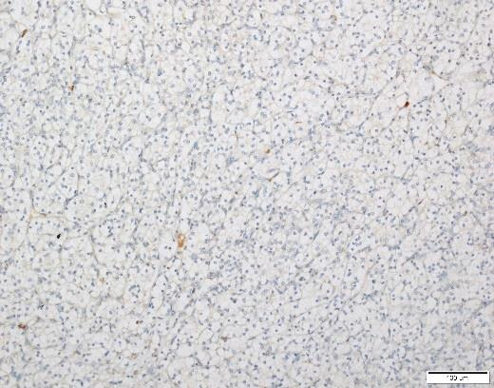

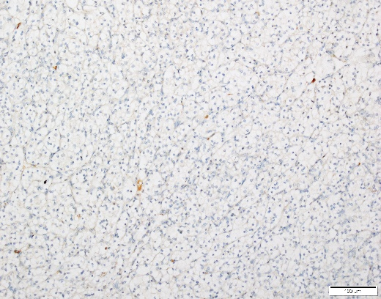

A Expression of PDL1, high intensity, IHC x100

Expression of PDL1, high intensity, IHC x100

B Expression of PDL1, high intensity, IHC x100

Expression of PDL1, high intensity, IHC x100

B Expression of PDL1, high intensity, IHC x100

Expression of PDL1, high intensity, IHC x100

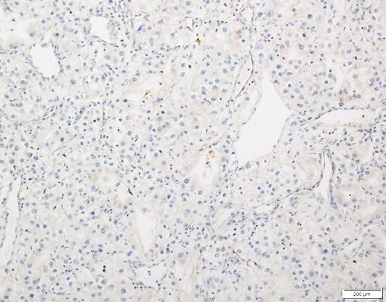

C Expression of PDL1, high intensity, IHC x100

Expression of PDL1, high intensity, IHC x100

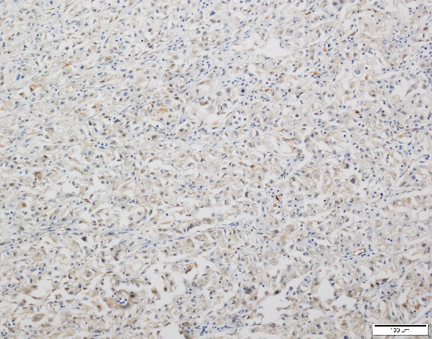

D Expression of PDL1, high intensity, IHC x100

Expression of PDL1, high intensity, IHC x100

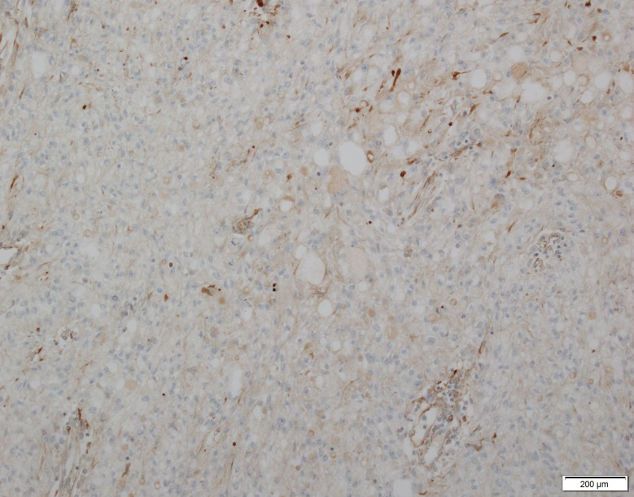

F Expression of PDL1, high intensity, IHC x100

Expression of PDL1, high intensity, IHC x100

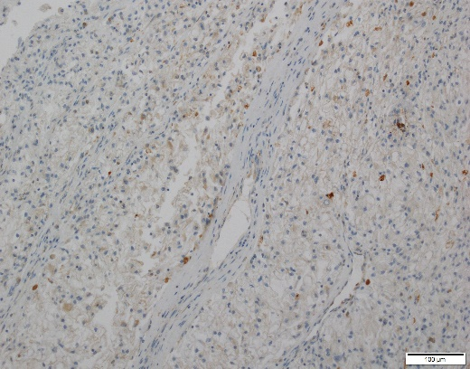

E Expression of PDL1, high intensity, IHC x100

Expression of PDL1, high intensity, IHC x100

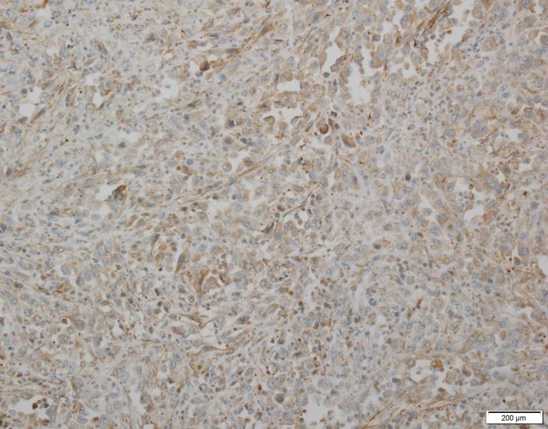

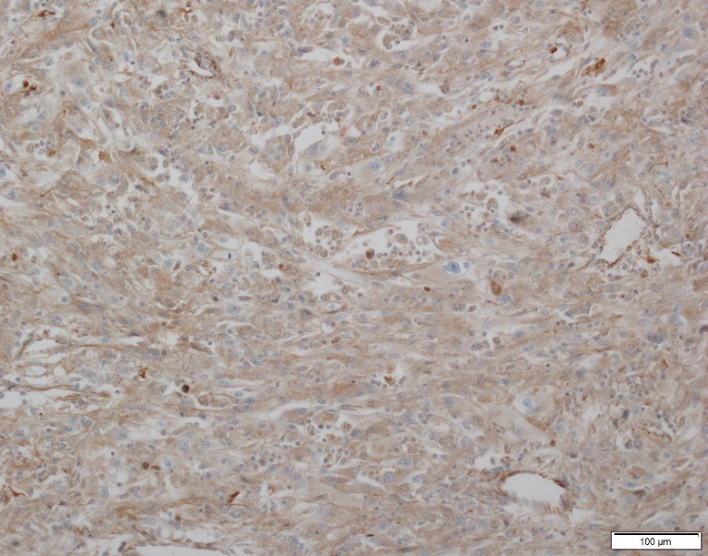

G Expression of PDL1, high intensity, IHC x100

Expression of PDL1, high intensity, IHC x100

H Expression of PDL1, high intensity, IHC x100

Expression of PDL1, high intensity, IHC x100

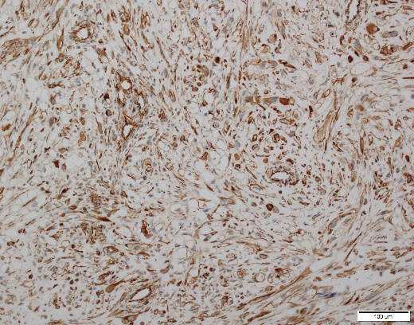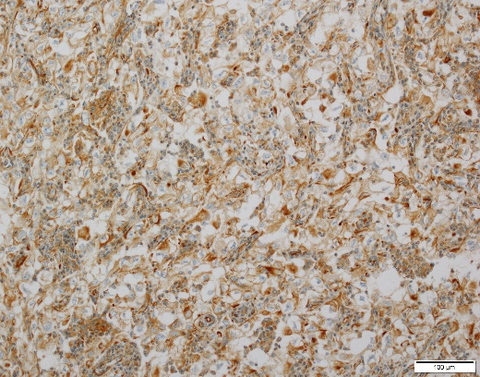

J Expression of PDL1, high intensity, IHC x100

Expression of PDL1, high intensity, IHC x100

I Expression of PDL1, high intensity, IHC x100

Expression of PDL1, high intensity, IHC x100

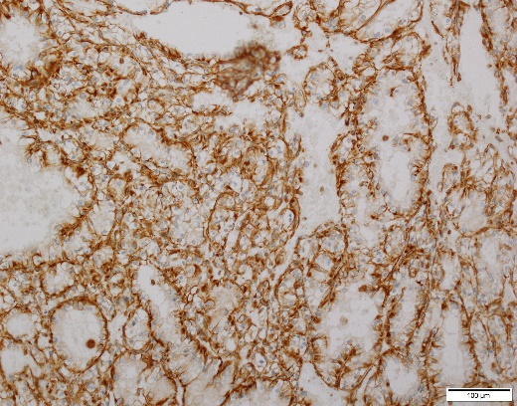

K Expression of PDL1, high intensity, IHC x100

Expression of PDL1, high intensity, IHC x100

**Figure III: sarcomatoid component**, HES x100 (A et B)

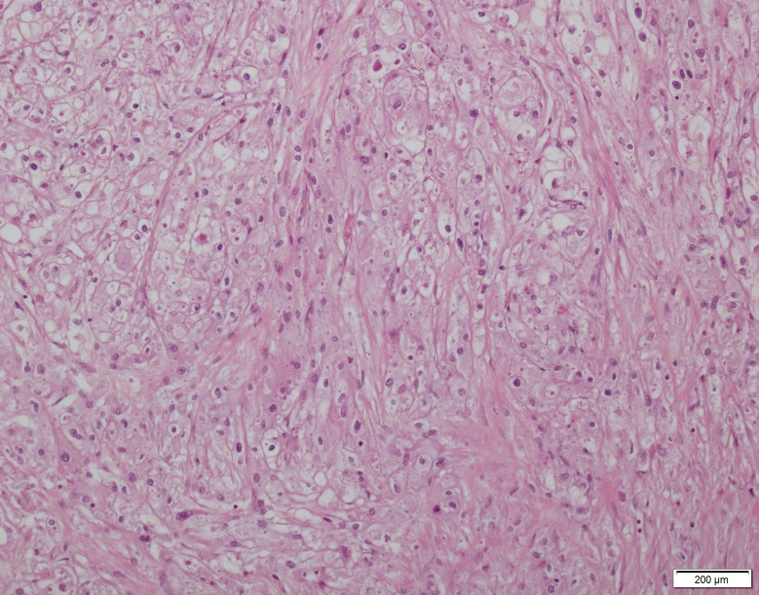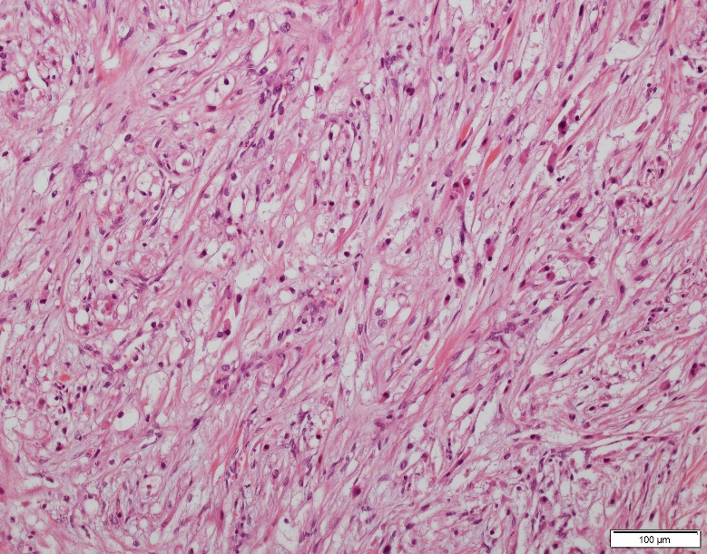

B Expression of PDL1, high intensity, IHC x100

Expression of PDL1, high intensity, IHC x100

A Expression of PDL1, high intensity, IHC x100

Expression of PDL1, high intensity, IHC x100

**Figure IV: CAIX immunostaining:**

1. Absence of CAIX staining, IHC x100
2. Membranous expression of CAIX in 100% tumor cells, IHC x100

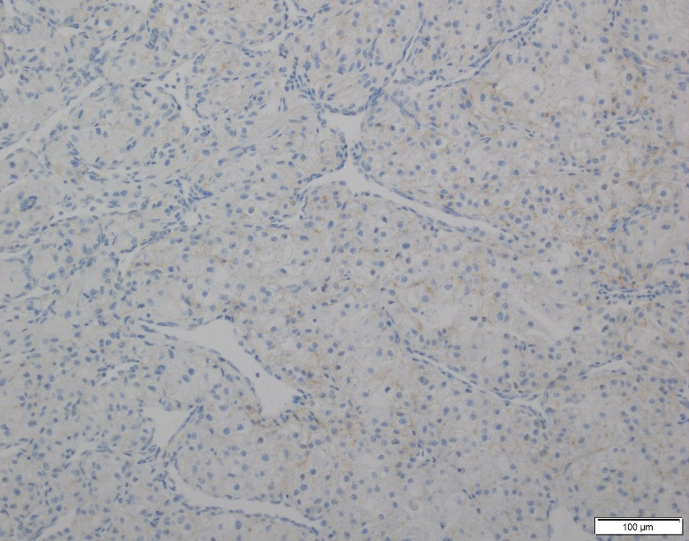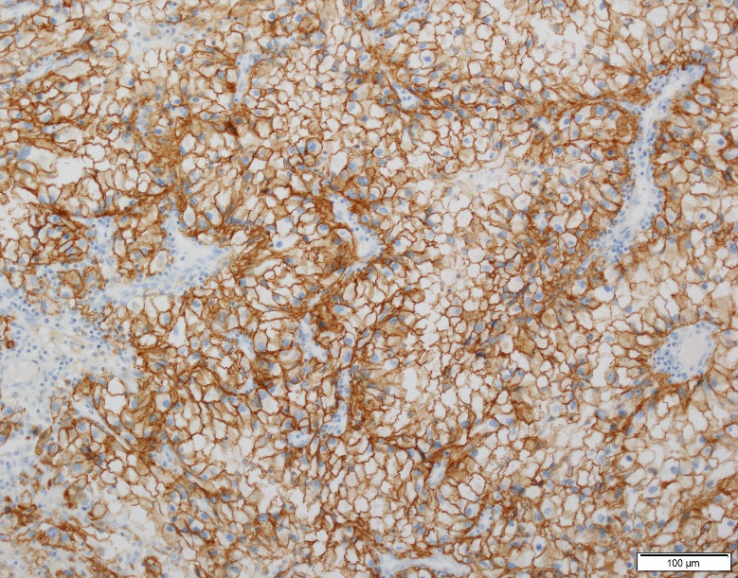

B Expression of PDL1, high intensity, IHC x100

Expression of PDL1, high intensity, IHC x100

A Expression of PDL1, high intensity, IHC x100

Expression of PDL1, high intensity, IHC x100

**Figure V: PAR3 immunostaining**

1. Membranous expression of PAR3, IHC x100
2. Membranous and cytoplasmic expression of PAR3, IHC x100

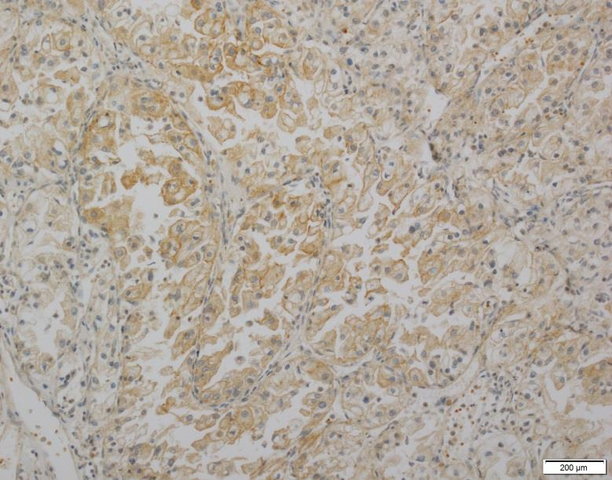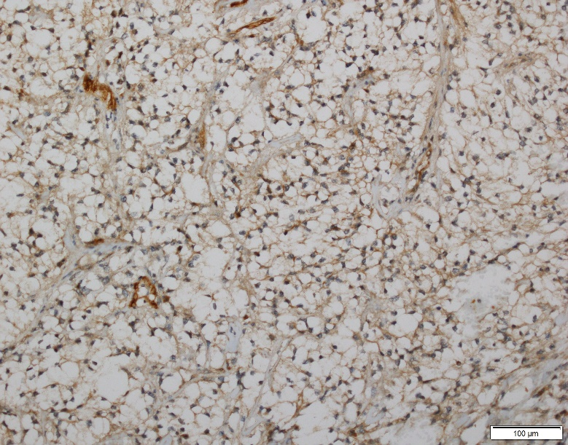

B Expression of PDL1, high intensity, IHC x100

Expression of PDL1, high intensity, IHC x100

A Expression of PDL1, high intensity, IHC x100

Expression of PDL1, high intensity, IHC x100

**Figure VI: VEGFA immunostaining**

1. Absence of VEGFA staining, IHC x100
2. Cytoplasmic expression of VEGFA in 100% tumor cells, IHC x100

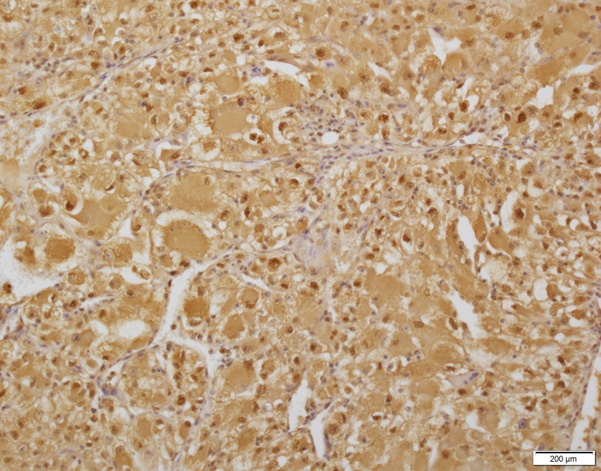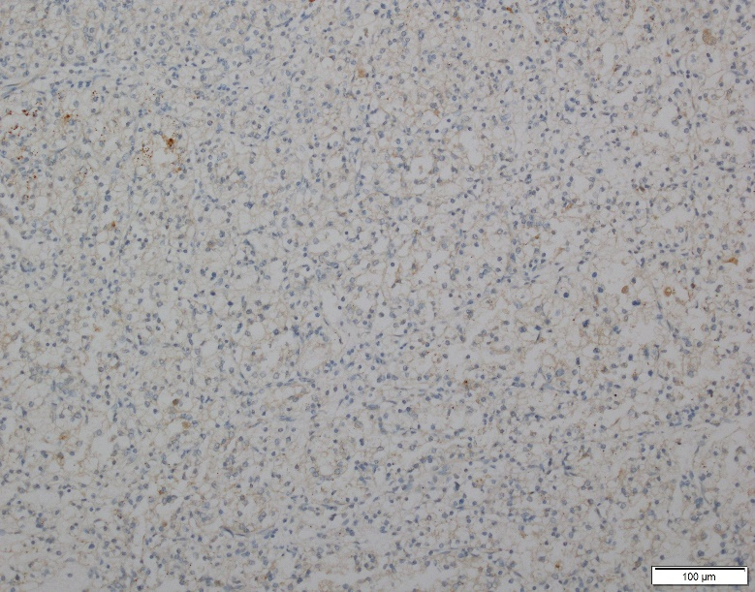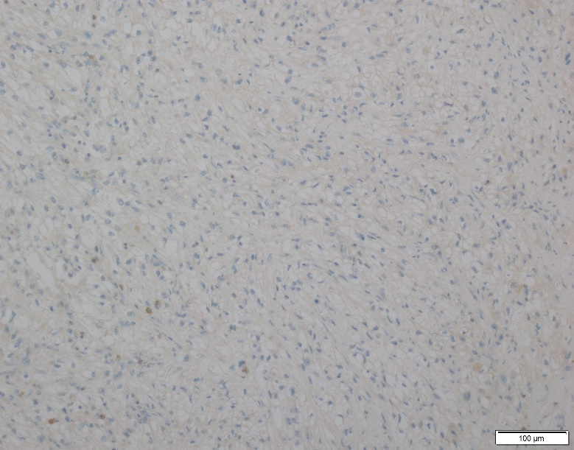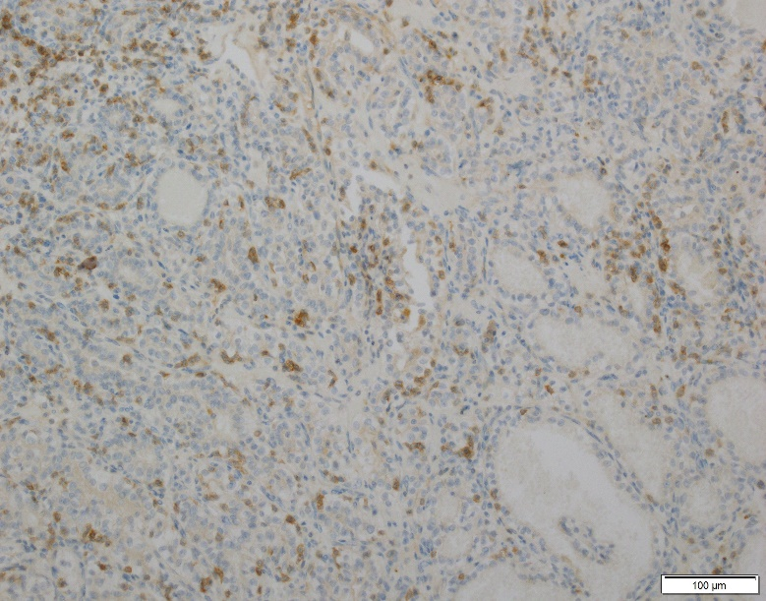

B Expression of PDL1, high intensity, IHC x100

Expression of PDL1, high intensity, IHC x100

A Expression of PDL1, high intensity, IHC x100

Expression of PDL1, high intensity, IHC x100

**FigureVII: PD1 immunostaining**

1. Absence of PD1 expression, IHC x100
2. Dense PD-1 expression in tumor-infiltrating lymphocytes, IHC x100

B Expression of PDL1, high intensity, IHC x100

Expression of PDL1, high intensity, IHC x100

A Expression of PDL1, high intensity, IHC x100

Expression of PDL1, high intensity, IHC x100